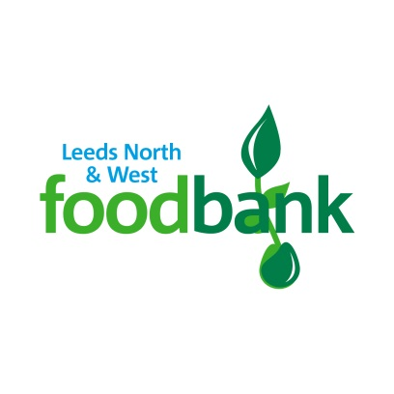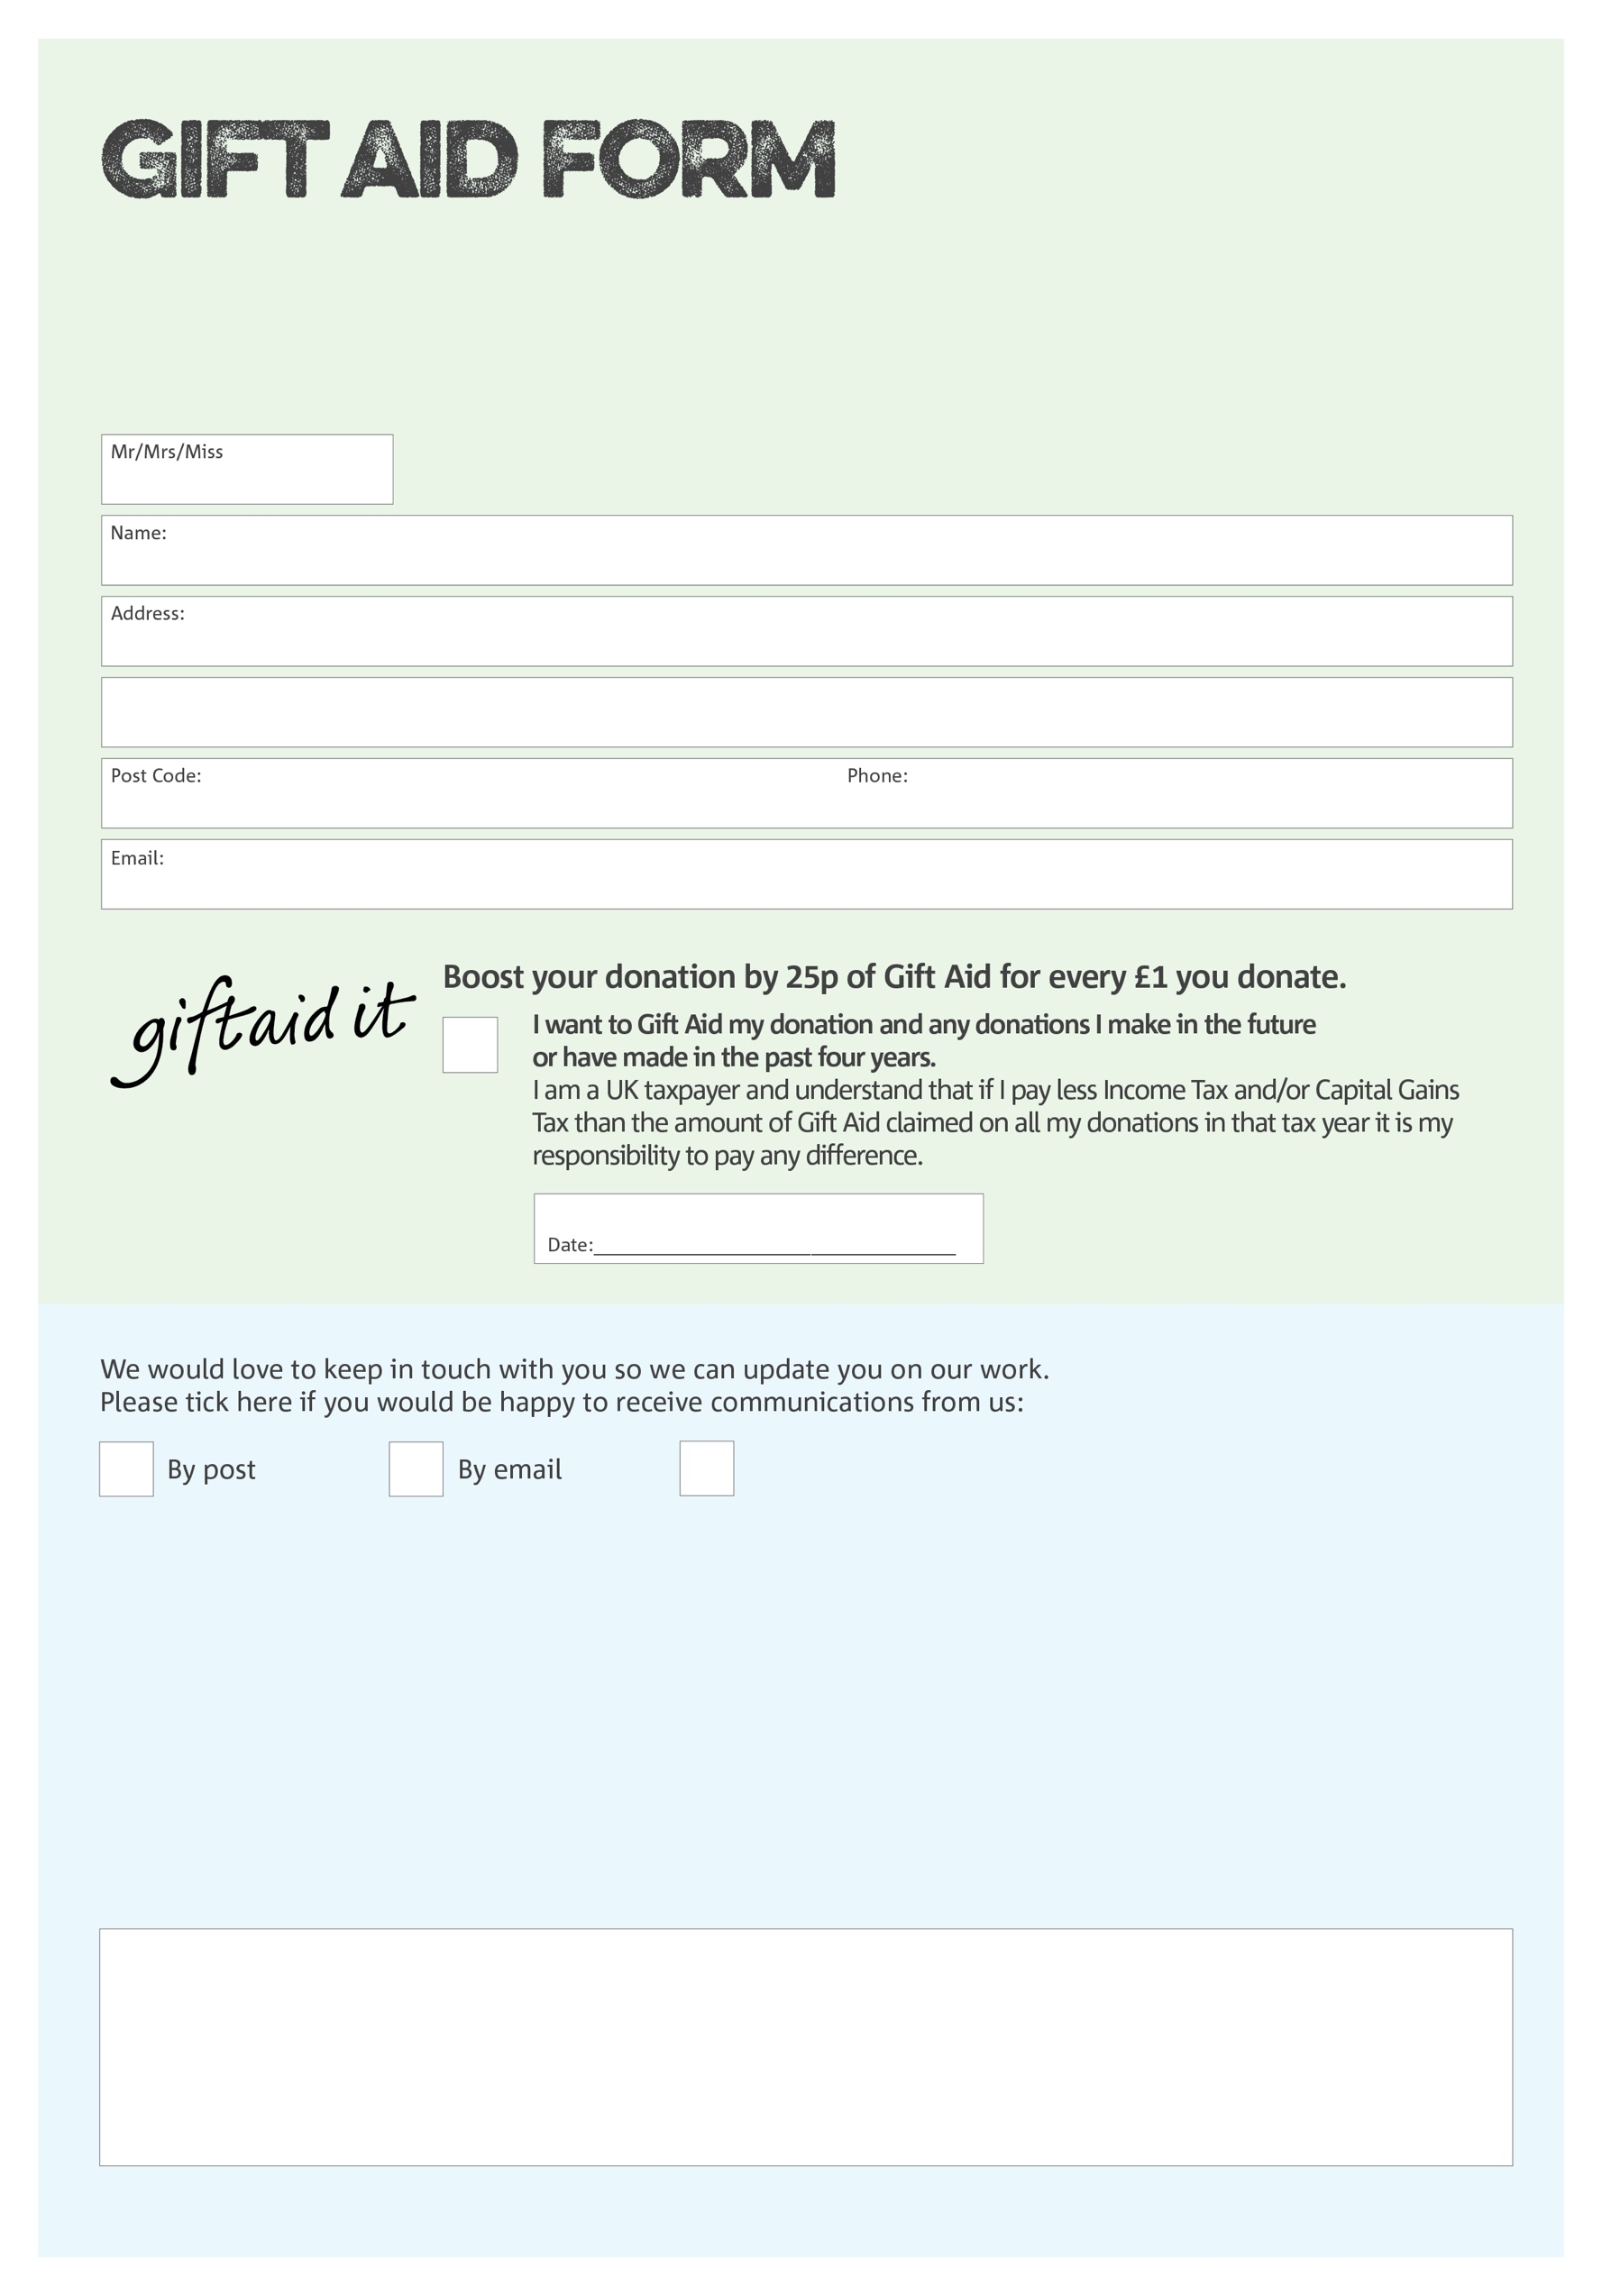

By filling in this form Leeds North and West Foodbank will receive an extra 25p for every £1 you give at no extra cost to you. Thank you!

**Data protection**

*'Leeds North and West Foodbank is committed to protecting your privacy and will process your personal data in accordance with current Data Protection legislation. Leeds North and West Foodbank collects information to keep in touch with you and supply you with information relating to our work. To unsubscribe from our newsletter, send a message to the email address above with the word unsubscribe in the subject line. A full data privacy statement for financial donors is available from the foodbank on request.’*

You can change your preferences any time by contacting us on 0113 2444696 or emailing us at

finance@leedsnorthandwest.foodbank.org.uk

I do not wish to receive future communications from Leeds North and West Foodbank

We would love to know why you have chosen to donate to Leeds North and West Foodbank. If you would like to share your motivation let us know below:

Charity Number 1162983. Registered in England and Wales